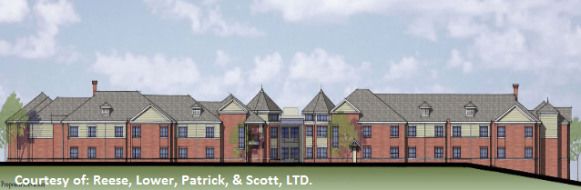
Project Delivery: GMP Enclosure: Brick Veneer (3-5/8” x 7-5/8”) Asphalt Shingles Occupancy: 128 Beds New Construction: 66,455 SF Renovation Work: 40,000 SF Project Phasing: Phase 1 – Site Development Phase 2 – New Additions Phase 3 – Connect Additions Phase 4 – Heavy Renovations Phase 5 – Light Renovations

Foundation: Caissons Grade Beams Spread Footings CIP Concrete: 4” Slabs-on-Grade 2” Topping Slabs 1st Floor Form Walls Precast Concrete: Solid Core Concrete Planking Masonry: CMU Bearing Walls (8”x16”) Roof: Wood Trusses Wood Sheathing
MEP
Structure
Cooling Tower: 90,000 CFM Boilers: 3 Natural Gas Boilers 1 – WSHP (1,9680 MBH) 2 – Hot Water (1,680 MBH) Condenser Pumps: 2 Pumps (826 GPM) Heat Recovery: 2 Units (2,500 CFM) Electrical System: 480/277V 3 Φ, 4 Wire Utility Feed: 15 kV Generator: 800 kW Fire Suppression: Wet Pipe Sprinkler System
Construction
Masonic Village at Sewickley
Sewickley, PA
Project Overview

Owner: Masonic Villages of Pennsylvania CM: Weber Murphy Fox Architect: Reese, Lower, Patrick, & Scott Engineers: Macintosh Engineering, Alderson Engineering, Gateway Engineering Building Type: Retirement Home/Health Care Total Height: 3 Stories Project Cost: $22.8 Million Duration: Sept. 13, 2012 – Sept. 27, 2012 Address: 1000 Masonic Dr. Sewickley, PA 15143
Jason M. Drake
Architectural Engineering | Construction Option
http://www.engr.psu.edu/ae/thesis/portfolios/2012/JMD5306/index.html

